From: http://davidstockmanscontracorner.com/the-qt-pivot-and-the-long-drawdown-ahead/

The QT Pivot And The Long Drawdown Ahead
By David Stockman. Posted On Friday, June 15th, 2018
The casino got itself all bulled-up again yesterday because Mario said he'd keep eurozone interest rate pinned to the 0.0% bound for another 15 months, at least.
Apparently, visions of endless carry trade killings danced in the heads 0f the boys and girls in the fast money lane----perhaps signified by the Russell 2000 making another all-time high. It is now up 41%from election day 2016 and 365% from the March 2009 low.
So never mind that it traded yesterday at 90X LTM earnings. When you have been buying the dips with such spectacular success for more than 3300 days running, why would you worry about such a trifling matter as a virtually non-existent earnings yield?
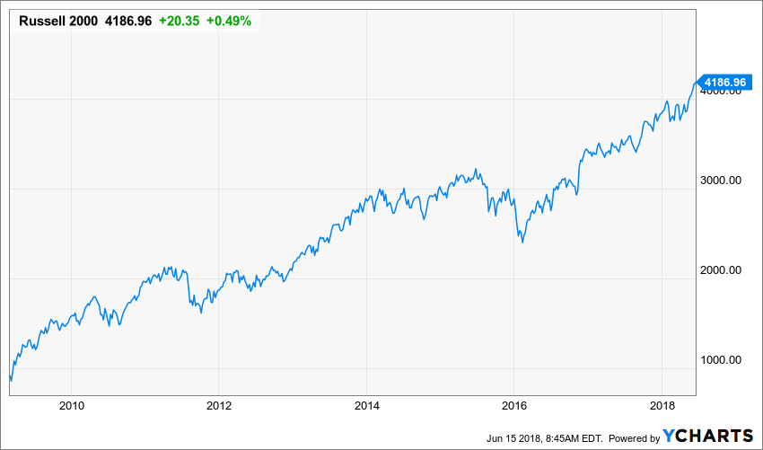
The truth of the matter, of course, is that this so-called index of America's main street companies has become an object of pure speculation and is being driven by bullish momentum and nothing more. Another stark reminder of that baleful condition came with this morning's release of the industrial production index for May.
It showed that despite all the ballyhoo about the US economy re-accelerating to 4.0% growth in Q2 (it's not as per below), industrial production is still flat-lining and manufacturing output is still actually 4% below its November 2007 pre-crisis peak.
Even on a short-term basis, there wasn't much to write home about. If you mind the mini-cycle in global trade and output owing to the China credit impulse (see below) between 2014 and the present, these are the bare facts: To wit, industrial production is up at a 0.52%% annual rate and manufacturing output has gained 0.50% per annum during the four years ending in May 2018.
And that ain't no boom; it's just a round trip which tracks with the China credit impulse (which is now rapidly cooling)
Nor is it any predicate for a stock market that has shot the moon; it's actually evidence that Fed's bubble finance pathologies have become so deeply embedded in the Wall Street casino that even the art of honest chart reading has been lost.
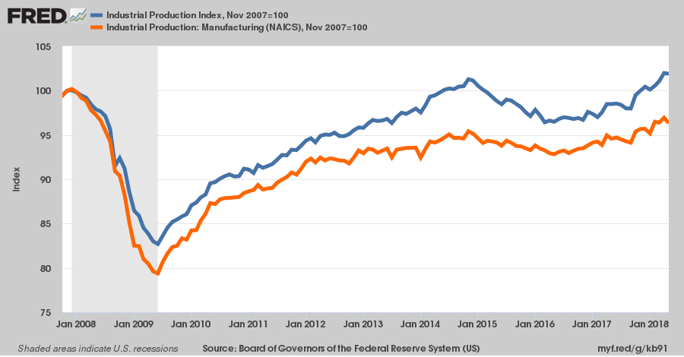
Yes, you can pretend that industrial production doesn't matter and sing the praises of the Services Economy all day long. Or even fairly note that if it is Pilates studios and nursing homes that consumers want, then that is exactly what the capitalist market will deliver.
But the fact remains, that even by the national GDP accounts, utilization of goods, materials and energy in the US economy was running at about $8 trillion annual rate or 40% of GDP in Q1. That included $1.5 trillion of durable consumer goods, $2.9 trillion of non-durables, $2.6 trillion of business capital goods, $780 billion of residential housing construction and about $200 billion of additional production by gas and electric utilities (counted as "services").
Self-evidently, all that "stuff" has to come from somewhere, and to the extent that upwards of 10% of it reflects America's massive trade deficit in goods, that's a problem for sustainable growth of domestic output and corporate profits.
That is, when you are importing $2.34 trillion and exporting only $1.55 trillion of goods as the US did in 2017, that $800 billion shortfall means you have an economy that is not earning its keep and is literally living on borrowed time.
In that regard, we never cease to be amazed by a certain school of purported free traders who join their Keynesian fellow-travelers in a chorus of: Not to worry---it's all financed by capital inflows because capital wants to come to the land of the free and the home of the world's bravest debtors.
Well, in an accounting identify sense, of course that's true. But it also begs the question: Has the marginal source of that massive, continuous inflow over the last 40 years reflected a pure investment calculus, as implied by the apologists for the status quo?
The answer, of course, is a resounding, No it has not!
The marginal source and driving engine of America's $8 trillion foreign borrowing spree since 1987 is foreign central banks-----led by the People's Printing presses of China, Japan and the Eurozone. And most assuredly as their balance sheets expanded by upwards of $15 trillion since 1995, they were buying up US dollar and other securities based on mercantilism at home, not the prospect of superior investment returns abroad.
Stated differently, the massive rise of America's foreign debt since 1980 was not a reflection of honest capitalist investment on the global free market; it was the corrupt product of Keynesian central banking that was forcibly exported to the rest of the world by the issuer of the world's so-called "reserve currency".
Once upon a time, of course, sound finance people new that advanced economies export capital, as did Britain and France during their 19th century era of capitalist glory. They also knew, by contrast, that developing economies, such as the American west, Argentina, Australia and India, import capital in order to finance the purchase of investment goods and to construct the infrastructure of economic growth.
Accordingly, the fact that China's $2 per hour industrial work force has financed America's massively indebted consumers and governments does not merely turn sound economics on its head; it's a screaming indication that mercantilist central banks which caused this inversion of the natural order have made a bargain with the devil in the process.
To wit, they have swapped the sweat of their workers and the natural resources of their lands for the paper liabilities of an economy that has become buried in $69 trillion of public and private debt.
That's how the Fed got away with expanding its balance sheet from $200 billion when Alan Greenspan took the helm in August 1987 to $4.5 trillion at the peak of the Bernanke/Yellen QE madness.
But folks, a 22X central bank balance sheet expansion is the approximate equivalent of a colossal $4 trillion financial fraud.
That is to say, even by the 3% annual monetary growth standard of the Chicago School's freshwater Keynesian guru, Milton Friedman, the Fed's balance sheet today should be only $500 billion.
- So essentially, Greenspan and his heirs and assigns plucked $4 trillion of new dollar liabilities out of thin air (digital cyberspace, actually) and pumped it into a global financial system.
- In turn, these emissions were scooped up and sequestered by other central banks, who were pleased to describe their mercantilist FX interventions as the prudent accumulation of dollar reserves.
In effect, the global Keynesian central banking project has caused the laws of sound finance to be circumvented: Save for the egregious reciprocal money-pumping of the PPBOC, BOJ, ECB etc, the Fed's massive monetary expansion would have caused the dollar's exchange rate to collapse and the American economy to succumb to an inflationary firestorm.
Alas, the massive FX accumulations of foreign central banks caused that condign punishment [con- means "together, altogether" and dignus means "worthy." So, something that is condign is deserved or appropriate. It especially applies a punishment that is severe but just, meaning the punishment is appropriate for the crime. ] to be displaced from the real economy of main street to the global financial system centered on Wall Street. When the East Asian and the Persian Gulf central banks especially bought up these fantastic dollar emissions hand-over-fist on the Keynesian illusion that their export industries and domestic economies would otherwise perish, they perforce joined the global scheme of interest rate repression and financial asset inflation.
Needless to say, neither end of that fraught bargain is sustainable, and in fact is about ready to endure a trial by fire.
That is, the pivot to QT (quantitative tightening) by the Fed will cause global yields to rise materially, as is already evident in the growing EM debt crisis. At length, however, all central banks will be forced to follow the Fed down the hill of balance sheet shrinkage, just as they did on the way up.
The alternative would be collapsing, not rising, FX rates, but that foreign central banks can no longer tolerate. Having effectively debauched their own currencies buying dollars, they would be subject to withering capital flight and surging domestic inflation were they to attempt to fight the Fed on QT.

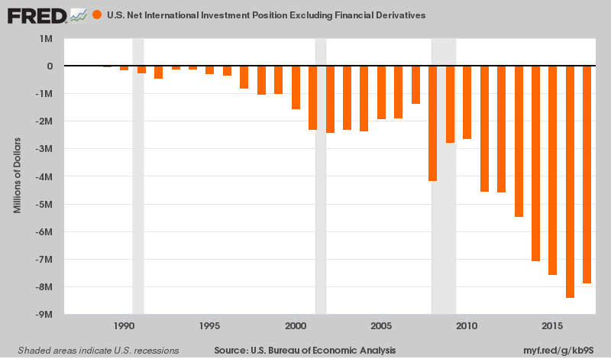
As is evident in the chart below, the world is about ready to move from a $2.5 trillion annual rates of central bank debt and security buying to break-even early next year, and then synchronized shrinkage thereafter.
With the Fed already ramping to a $600 billion rate of bond-dumping in Q4, it would not take much to tilt the system toward a trillion dollar plus rate of shrinkage on a global basis soon thereafter. Perhaps the black swan that the casino players profess to be nowhere in sight is actually a green one----a massive global dollar shortage which will hit the world's $235 trillion accumulation of debt like a veritable financial cyclone.

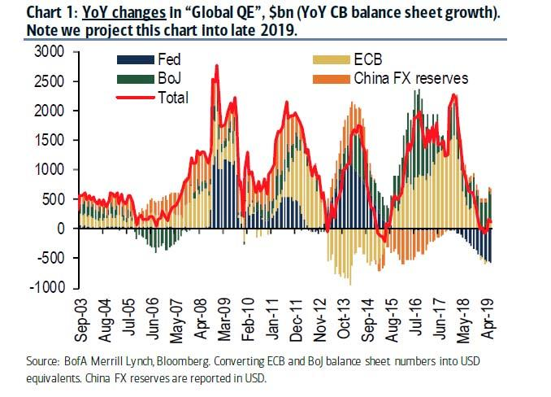
In any event, the October 2018 collision in the dollar bond pits is fully on schedule. Federal revenues are now dropping at nearly a 10% rate on a year/year basis owing to the utterly mis-timed, unfunded and fiscally reckless Trumpite/GOP tax cut of last winter---even as outlays are soaring in response to busting the budget caps and plowing upwards of $100 billion per year extra into military and national security spending.
That is, there will be $1.8 trillion of homeless government paper flooding into the bond pits come FY 2019----$1.2 trillion in new treasury borrowings and $600 billion of old bonds rolling off the Fed's balance sheet. In turn, that will trigger the mother of all "yield shocks", thereby bringing the Green Swan to every nook and cranny of the global financial system.
Needless to say, Wall Street's latest delusion---that the debt-burden, under-invested, financially strip-mined mainstreet economy is about to take off at 4.0% growth or more----will be long forgotten by October.
We are referring, of course, to yesterday's financial media headline proclaiming, "U.S. Retail Sales Soared in May”.
They did not. There is clearly an anomaly in the data, which showed auto sales growth of 0.5% during the month, when the detailed industry report on unit sales actually showed a 1.8% decline to an annualized sales pace of only 16.8 million units.
As the always perceptive David Rosenberg observed this morning, the actual retail sales gain for May was probably about 0.3% after you correct for the auto anomaly, and 0.0% in real terms when you factor in inflation running at a hot 2.7% annual rate.
In fact, real retail sales on a year over year basis are only running at a 3.1% pace, and even that is due to the collapse of the savings rate to a generational low. The notion of America's geriatric 108 month old business cycle is fixing to spring out of the starting blocks is simply another Wall Street lie designed to lure the mullets into the casino for one more bit at the dip.
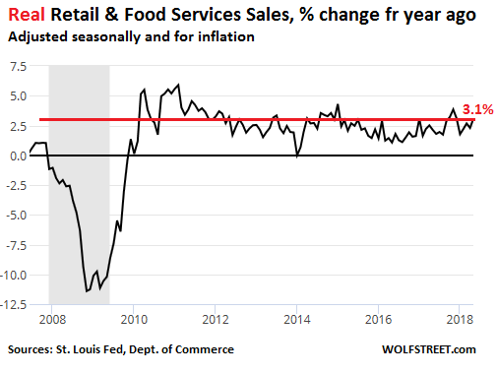
At the end of the day, something very different lies ahead. Namely, a epochal correction in financial asset markets which may last for years---even decades. Last time the draw down lasted 2,000 days [5.5 years]---and even that has already been forgotten.
The next one won't be.

